Work order issue

1. Create new routing detail on work order – 0000000016

In the detail of the work order mentioned above (0000000016)

1. We tried creating a new component detail it does not work. The screen just hangs
2. 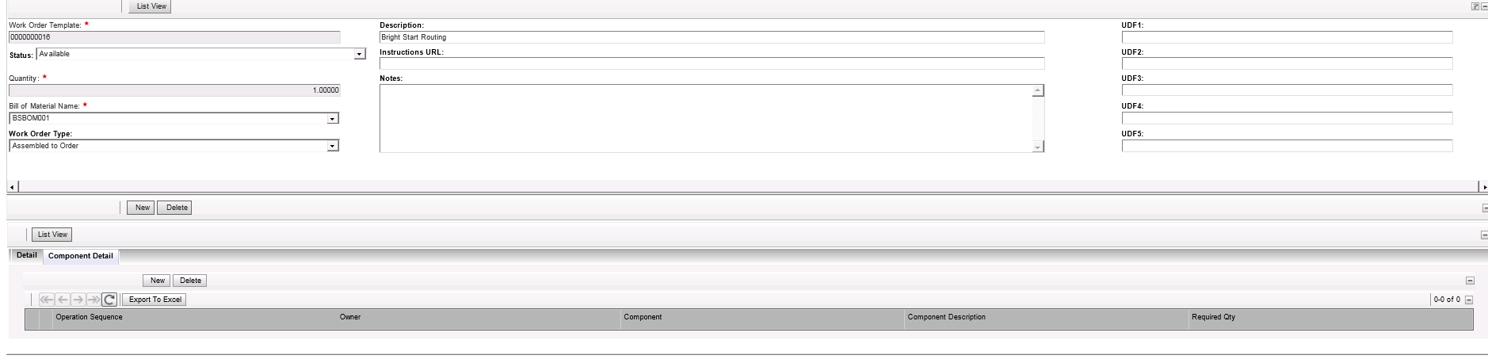
3. When checking the memory of the UAT server, we notices it is increasing drastically. But nothing happens. We cannot proceed in creating the component detail.
4. 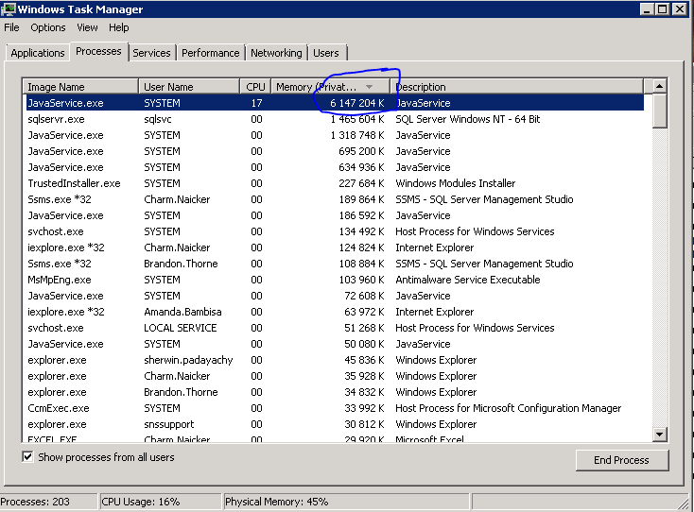
5. I got the following error as well
6. 